1. Models University **CLASS DIAGRAM** (course, lecturer, student and interface person)

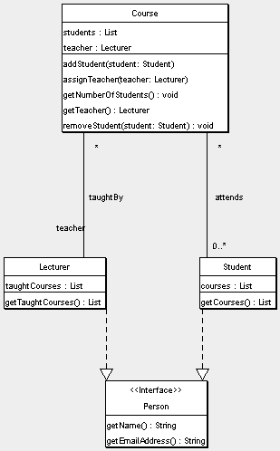

1. National Hockey League **ER DIAGRAM**

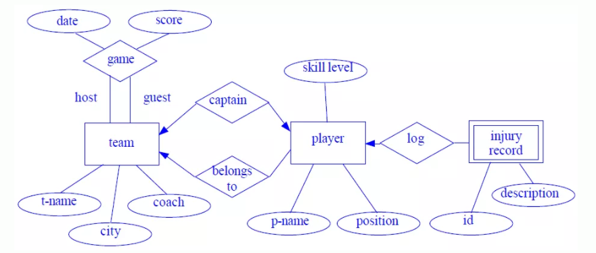

1. ATM Cash Withdrawal **DEPLOYMENT DIAGRAM**

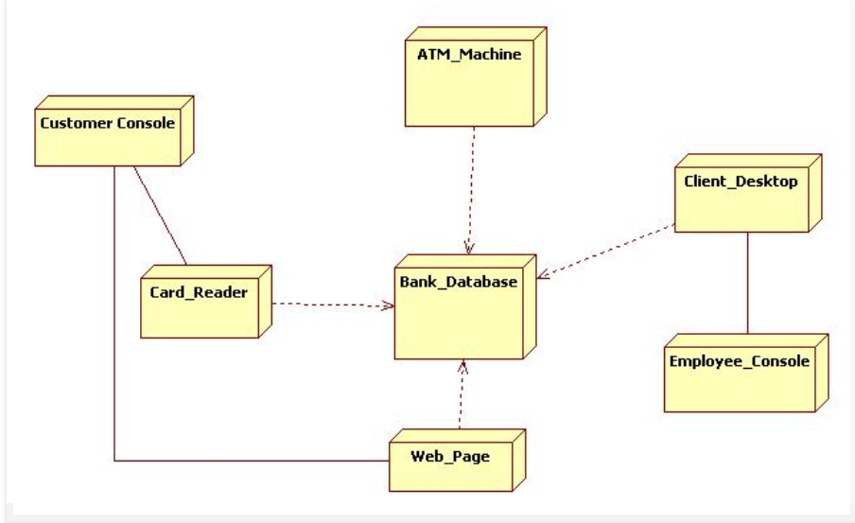

1. Medical Management System **COMPONENT DIAGRAM**
2. Web Customer **USE-CASE**
3. **TopLevel**

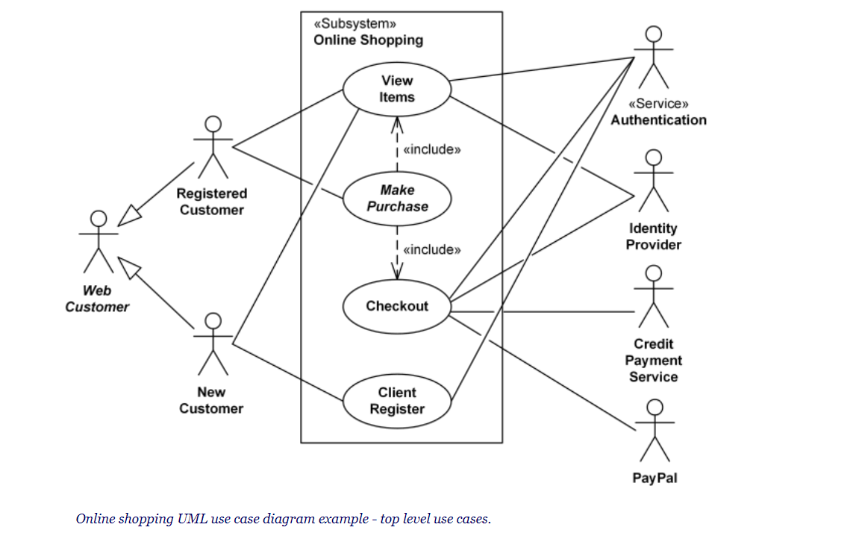

1. **ViewItems**

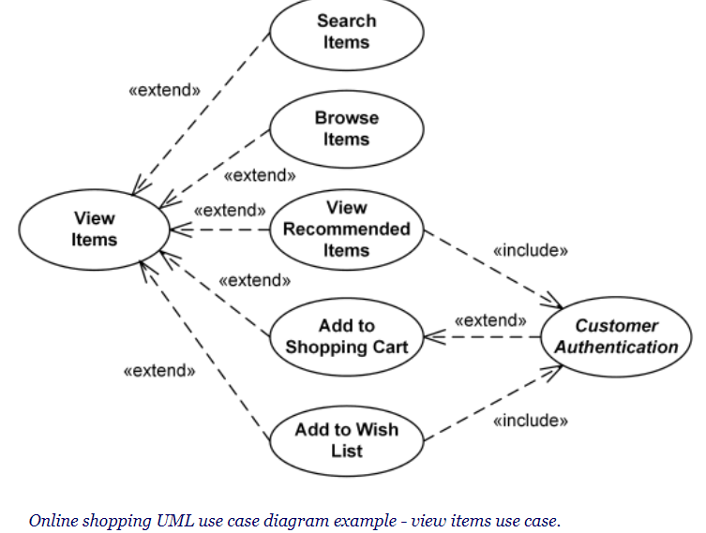

1. **Checkout, authentication and payment use cases.**

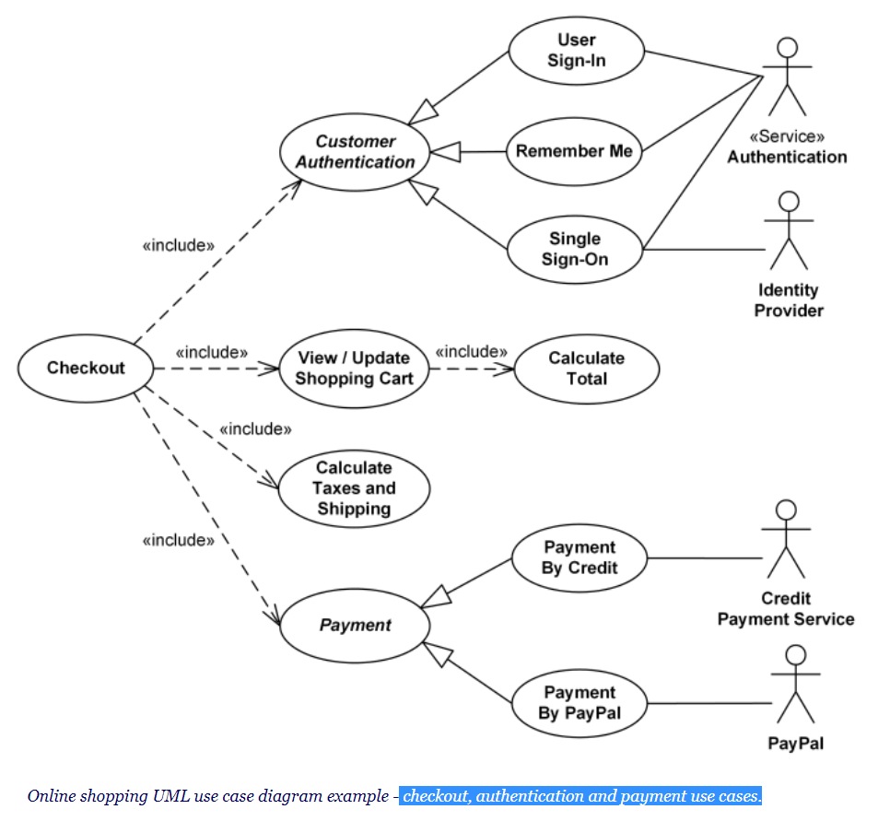

1. Model Companies payroll **CLASS DIAGRAM**

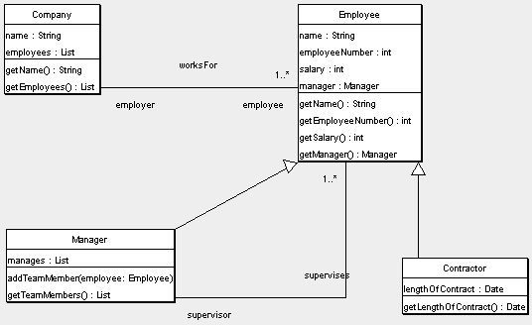

1. Library (liscensed) **SEQUENCE DIAGRAM**

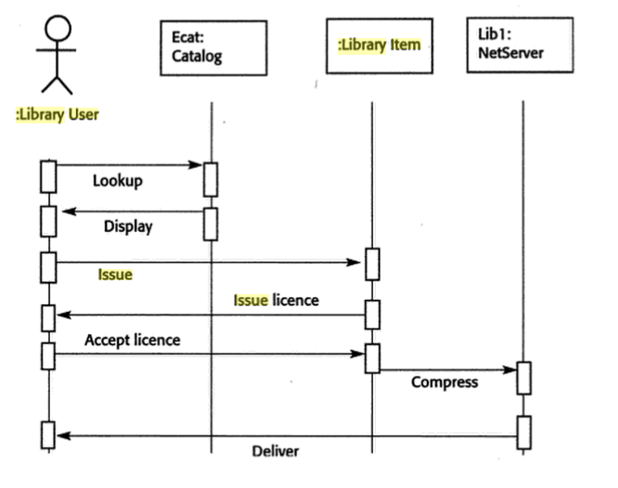

1. Web Based Application Friend Request **STATE DIAGRAM**

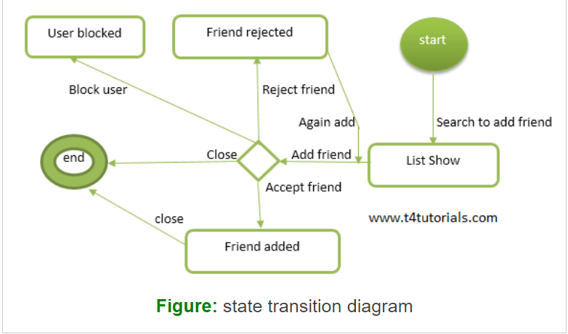

1. Atm Machine withdraw cash **COLLABORATION DIAGRAM**

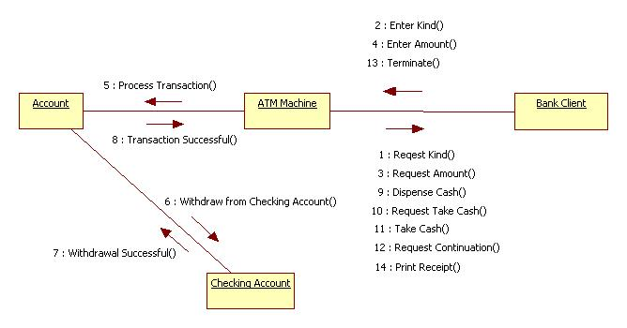

1. Author **ACTIVITY DIAGRAM**



1. University Registrar Office **ER DIAGRAM**

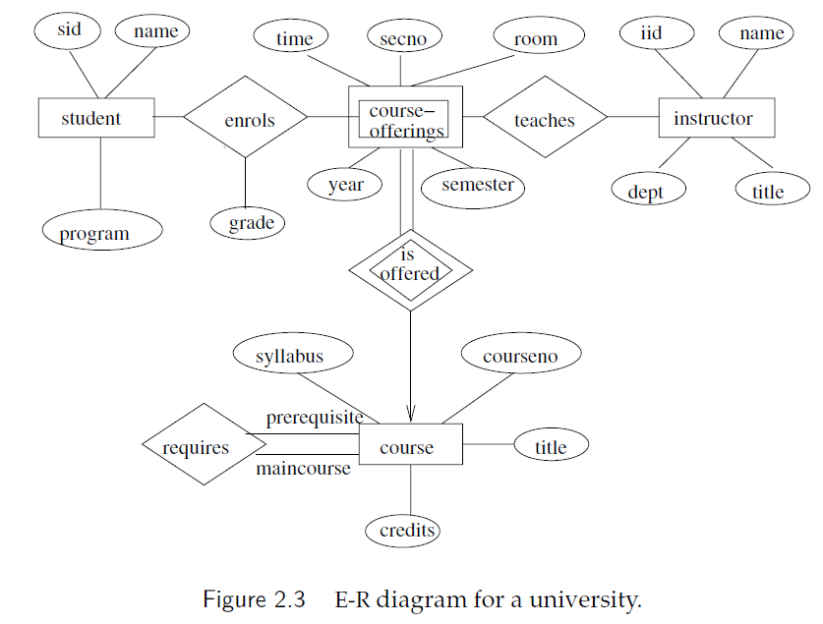

1. Online BookShop **SEQUENCE DIAGRAM**

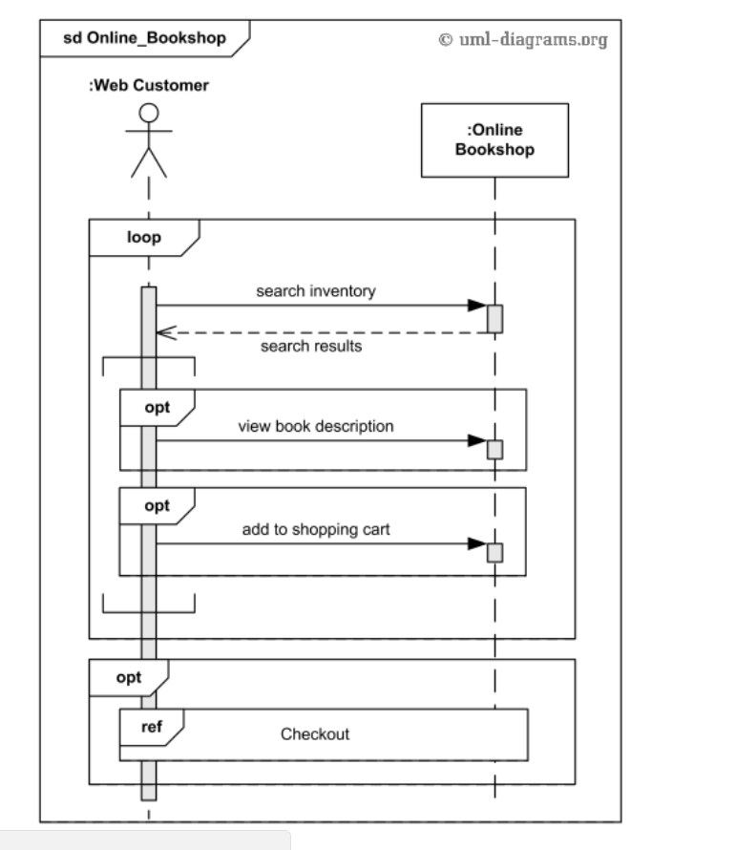

1. Library Management **CLASS DIAGRAM**

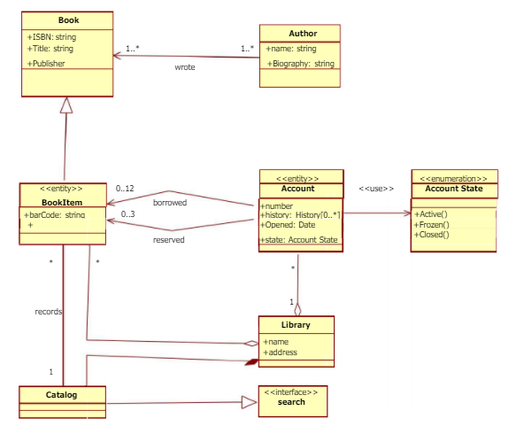

1. Music Portal System **USECASE DIAGRAM**

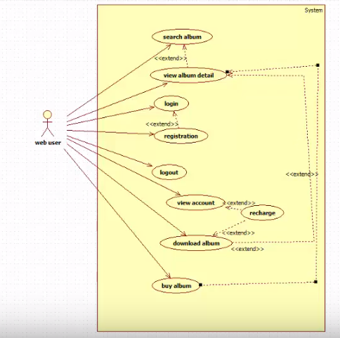

1. Coffee Brewing Machine **STATE CHART DIAGRAM**

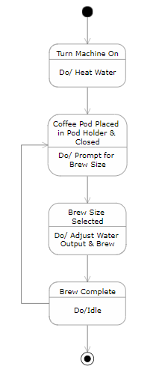

1. Video Rental LTD **STATE DIAGRAM**
2. **Context Level**

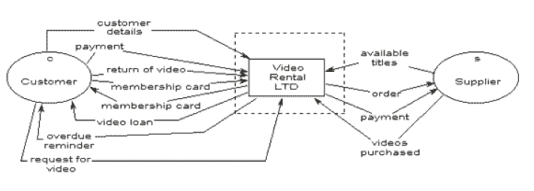

1. **Level 1 DFD**

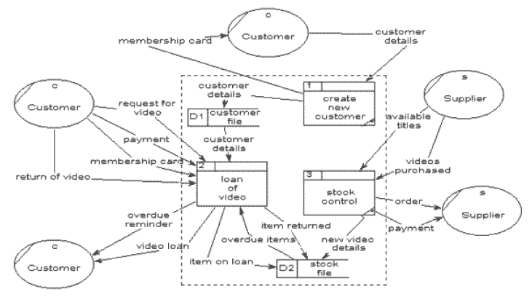

1. **Level 2 DFD**

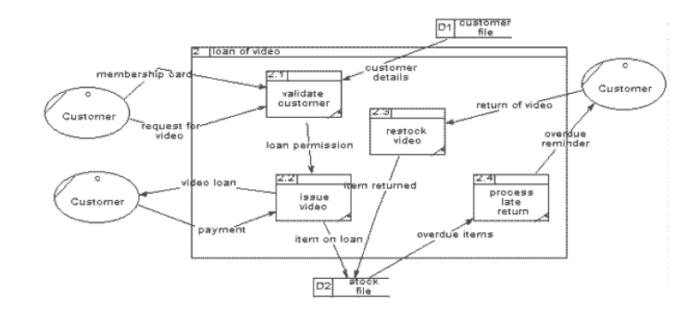

1. Order Processing System **ACTIVITY DIAGRAM**

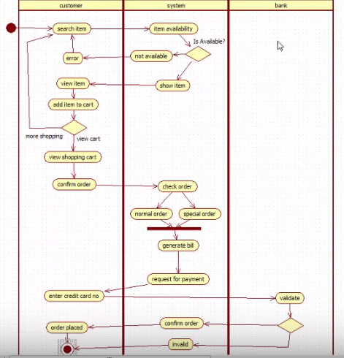

1. Hospital Reception System **USECASE DIAGRAM**

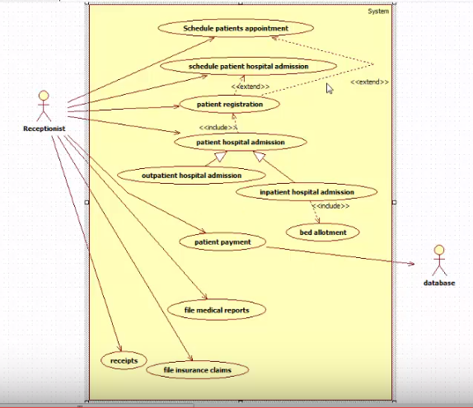

1. Order Management **ACTIVITY DIAGRAM**

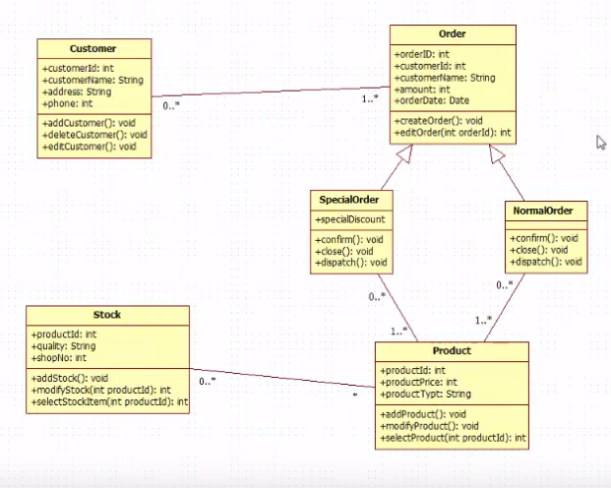

1. Hotel Reservation System **STATE CHART DIAGRAM**

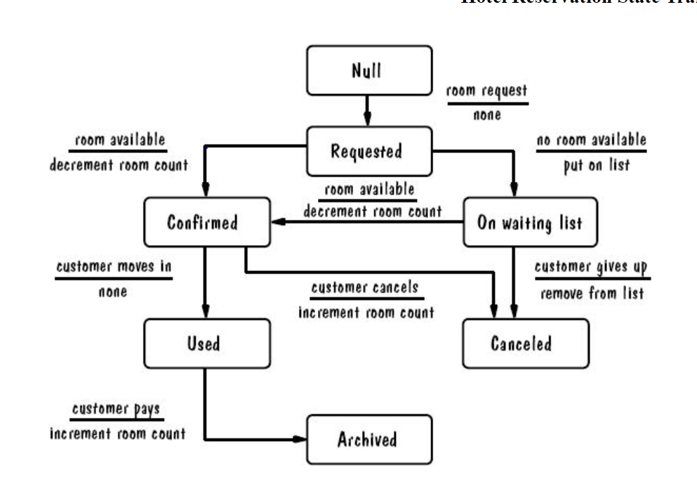

1. ATM Cash Withdrawal **ACTIVITY DIAGRAM**

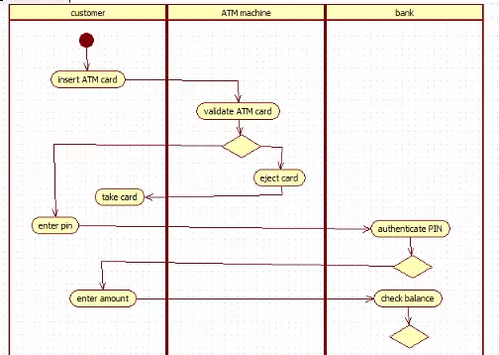

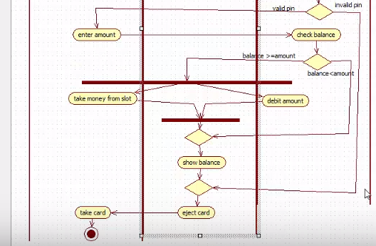

1. Pizza Supreme **DATA FLOW DIAGRAM**
2. **Context Level**

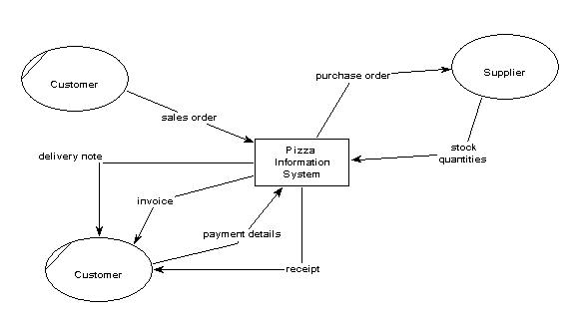

1. **Level 1 DFD**

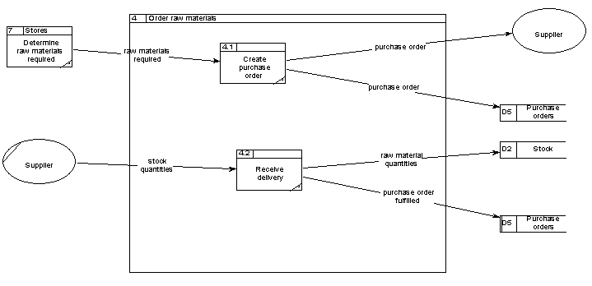

1. **Level 2 DFD**

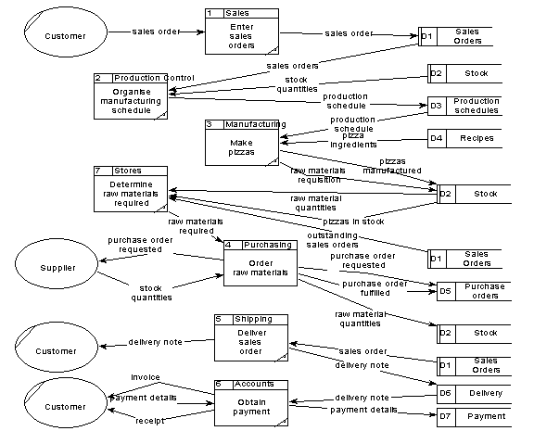

1. Point - Of - Sale POS **CLASS DIAGRAM**

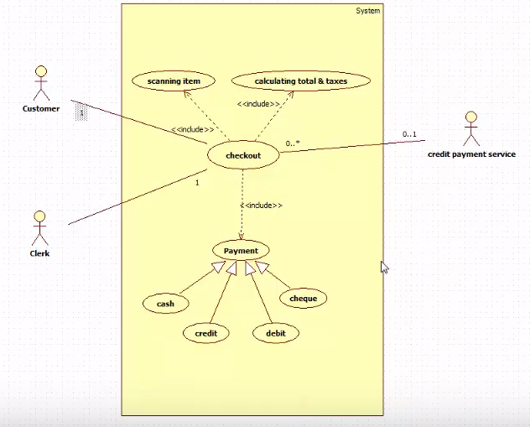

1. Airport Check-In Process **STATE DIAGRAM**

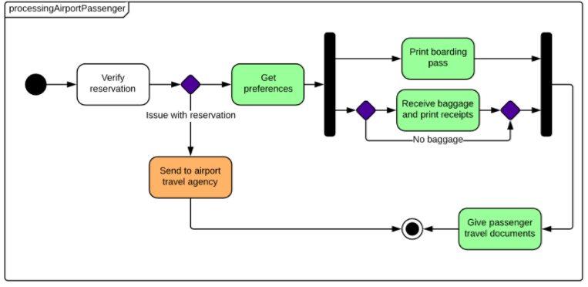

1. Hospital Management System **CLASS DIAGRAM**

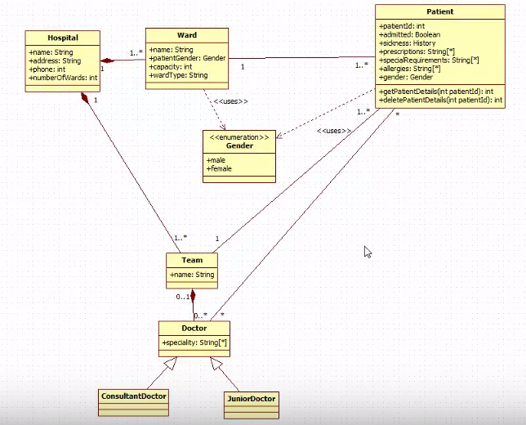

1. Estate Agency **data flow diagram**
2. 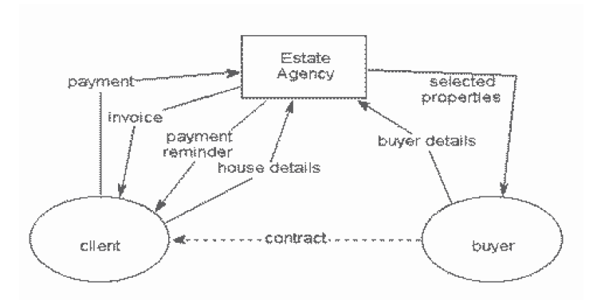**Context Level**
3. **Level 1 DFD**

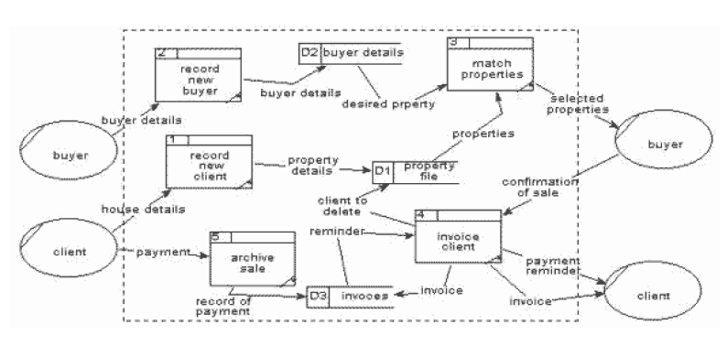

1. **Level 2 DFD**  
   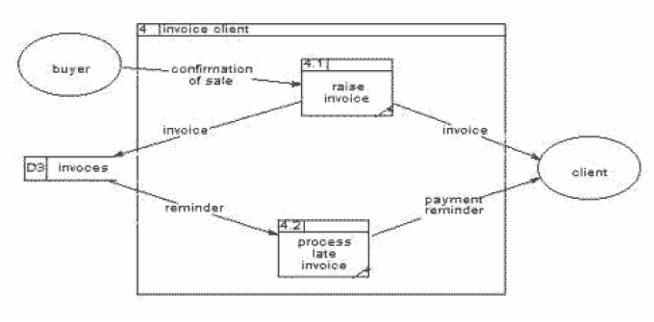
2. Ticket Vending Machine **ACTIVITY DIAGRAM**

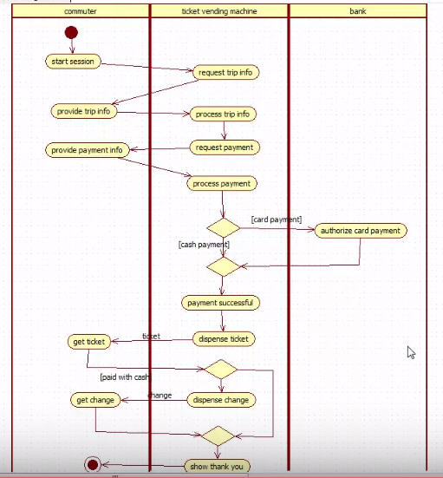

1. Vehicles **CLASS DIAGRAM**

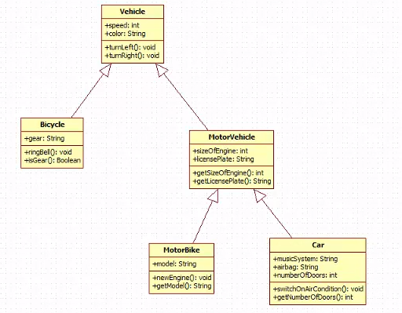

1. Online BookShop **COLLABORATION DIAGRAM**

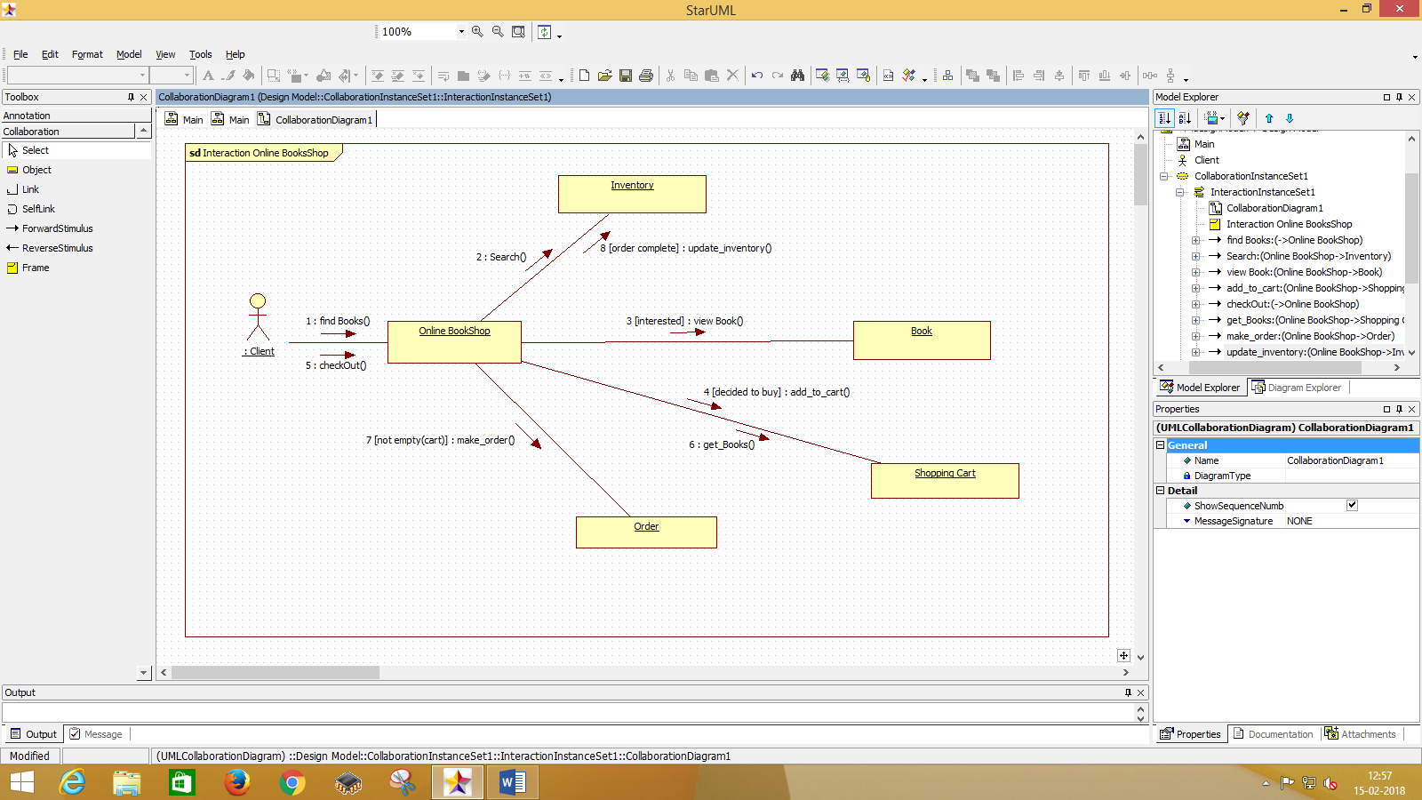

1. Correspondence Courses
2. ATM **SEQUENCE DIAGRAM**

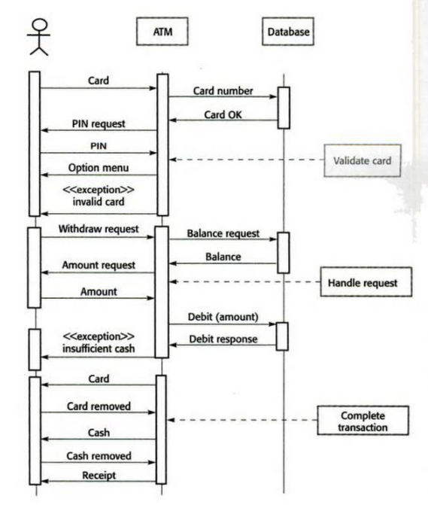

1. Online Shopping – User Account **STATE DIAGRAM**

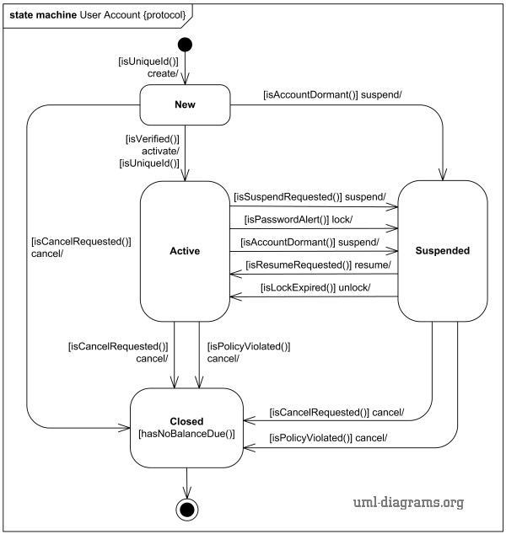

1. ATM **DATAFLOW DIAGRAM**

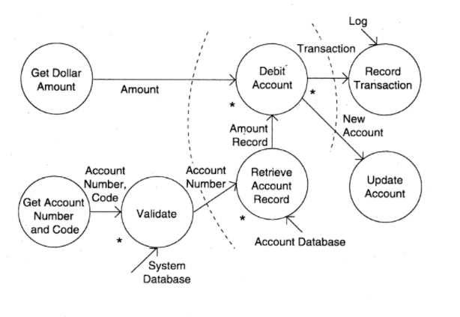

1. Invoice **ER DIAGRAM**



1. Apple iTunes **DEPLOYMENT DIAGRAM**

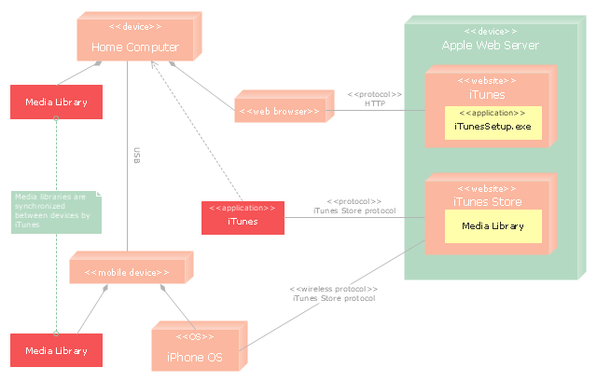

1. LIBSYS Downloading and Printing an Article **SEQUENCE DIAGRAM**

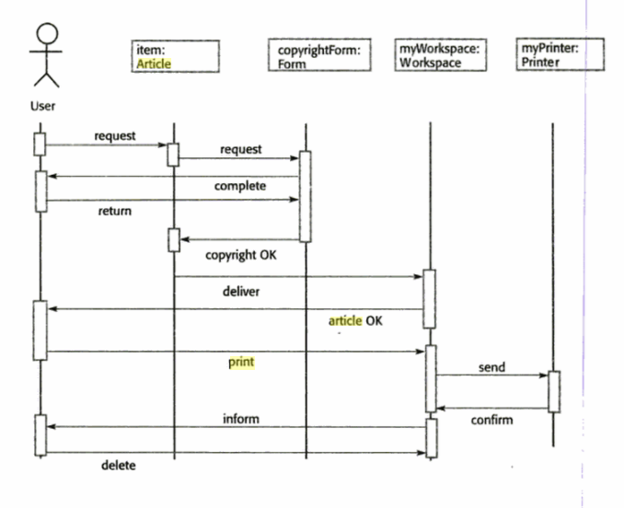

1. Water Phase **STATE DIAGRAM**

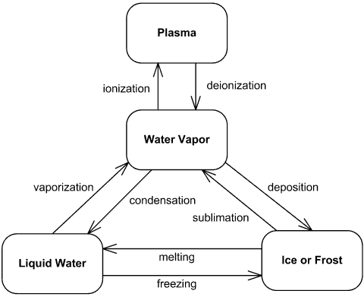

1. Buying an Article **ER DIAGRAM**
2. Workers Pay – Check **DFD DIAGRAM**

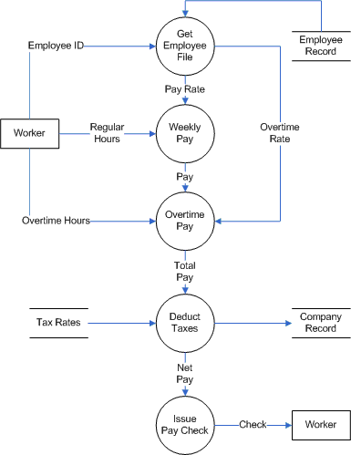

1. Airport Check – in and Security **ACTIVITY DIAGRAM**

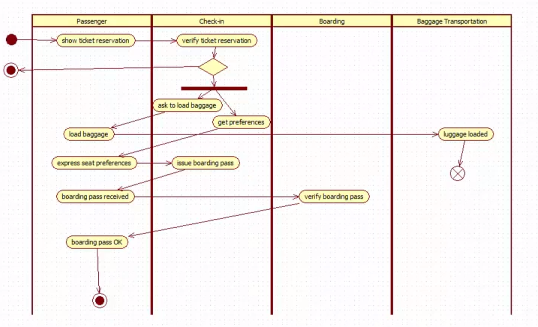

1. The Local City **ER DIAGRAM**

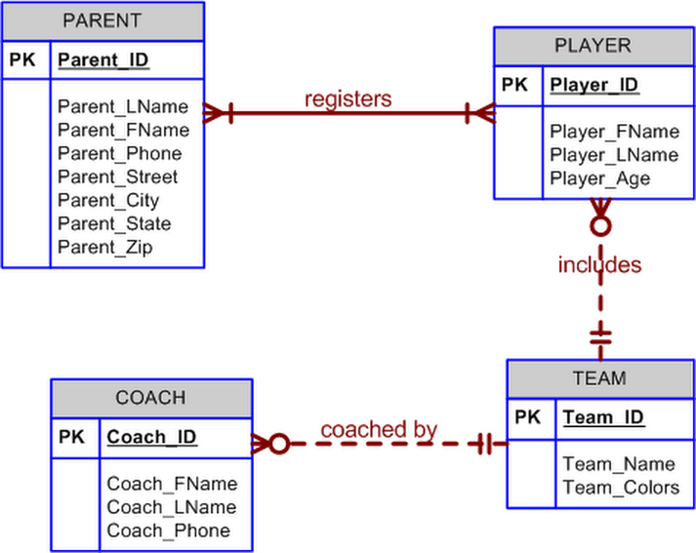

1. Library System **DATAFLOW DIAGRAM**
2. ATM **STATE DIAGRAM**

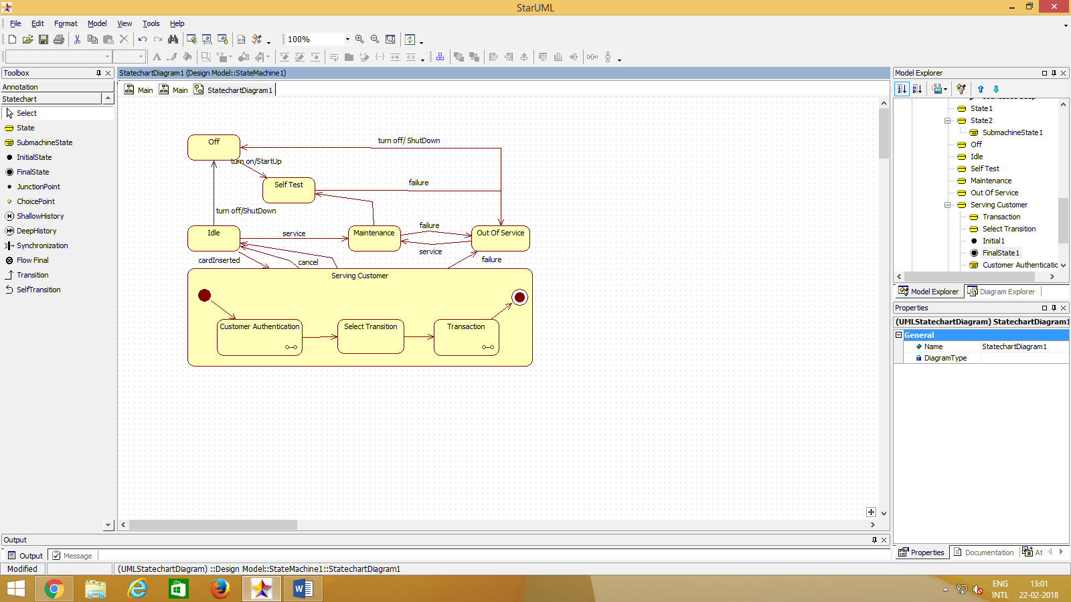

1. Order Processing System **DATA FLOW DIAGRAM**

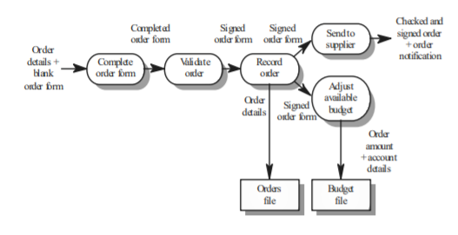

1. Credit Card Processing System **ACTIVITY DIAGRAM**

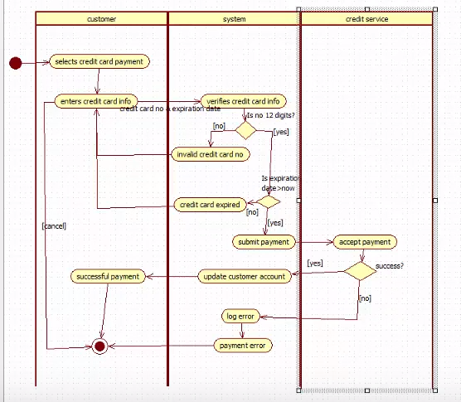

1. Online Examination **SEQUENCE DIAGRAM**
2. Examination Paper Preparation **ACTIVITY DIAGRAM**

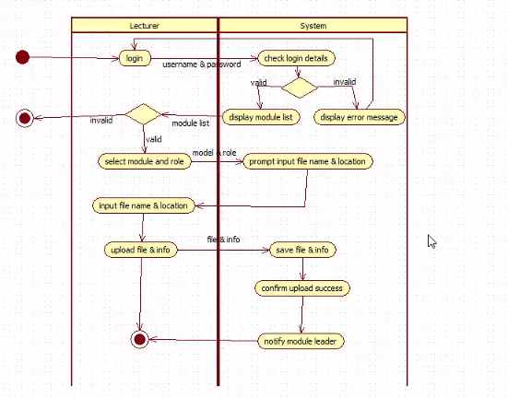

1. Insulin Pump **DATA FLOW DIAGRAM**



1. Librarian Calculates Fine **COLLABORATION DIAGRAM**